Plan
Project Title:
Hardware Accelerated YOLO on PYNQ for Smart Traffic Systems

Objective:
Improve the size of YOLO-based object detection, with negligible losing accuracy (traffic)

Week | Tasks
1 | 1. Prepare the knowledge needed for the project  2. Plan for the tasks
2 | 1. Toolchain setup (e.g., TF, TF Lite, PyTorch)  2. YOLO baseline model + dataset selection based on literature
3 | Layer by layer analysis of the baseline YOLO based on the literature (and our analysis)
4 | Model optimization analysis   Run a YOLO model on CPU/ GPU   Layer-based error injection and profiling
5 | Model optimization methods exploration   Quantization   Pruning
6 | Profiling + bottleneck analysis   layer-wise latency   memory   FPS   CPU usage
7 | Run YOLO inference on an embedded platform (e.g., ARM)
8 | Hardware / software partitioning  Which layers should be run on FPGA
9 | 1. Resource utilization  2. Latency & throughput measurement
10 | Comparison vs software baseline (accuracy vs speed trade-off)
11 | 1. Power & efficiency analysis  2. Final evaluation
12 | 1. Prepare figures, tables on what I worked  2. Draft and work on research paper

Week 1: 25-29 May 2026
Since I am completely new to this topic, I learned a few things about it before working on the project. Here is what I learned:

1. Image processing example (in traffic system)
Image Classification  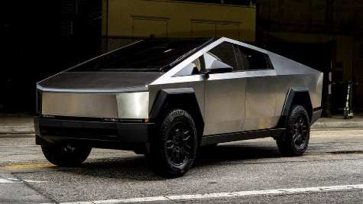  - There is a car  - Confidence: 98%  DNN models  Residual Network  - accurate  Efficient Net  - balanced accuracy and speed  More examples  Input  A traffic sign  Output  Is a stop / speed limit / yield sign  Input  A road of car  Output  It is low / medium / high traffic  Main use  Recognizing objects, e.g.:  - traffic sign  - road crowd level  - road weather | Image Detection  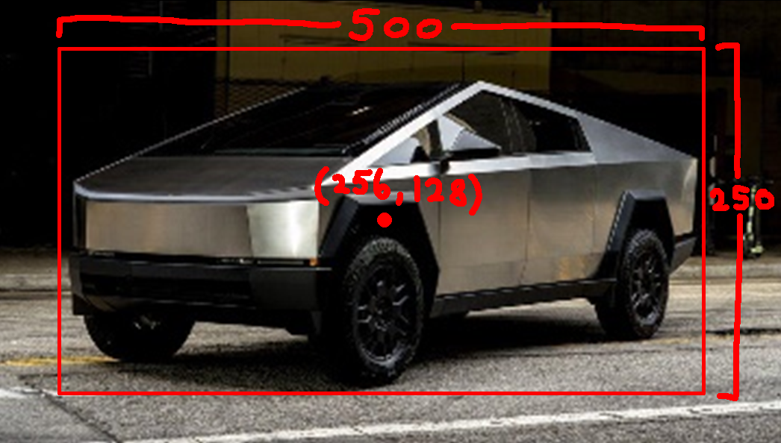  - There is a car  - Position: x=256, y=128  - Size: width=500, height=250  - Confidence=98%  DNN models  YOLO  - one stage detector  - very fast  Faster R-CNN  - accurate  More examples  Input  A Street photo  Output  the position, size of:  - cars  - human  - traffic lights  - etc.  Main use  Detect objects with their position and size, e.g.:  - cars  - human | Image Segmentation  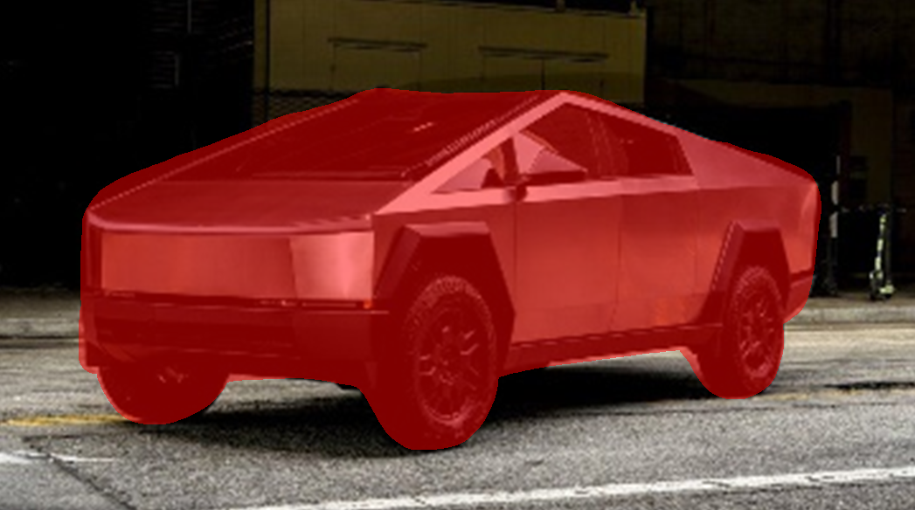  - There is a car  - including pixels: […]  DNN models  U-Net  - good at area separation  Mask R-CNN  - good at shaping objects  More examples  Input  A street photo  Output  Separate the Area of  - Road for cars  - Road for humans  - Roadblock  - Sky  - etc.  Main use  Splitting different areas, e.g.:  - cars can drive area  - humans cannot walk area

In this project, we will focus on image detection, with the DNN model YOLO.

2. YOLO (you only look once)
An image will be separated into tiles, each tile has:  [Pc Bx By Bw Bh C1 C2] to represent a box  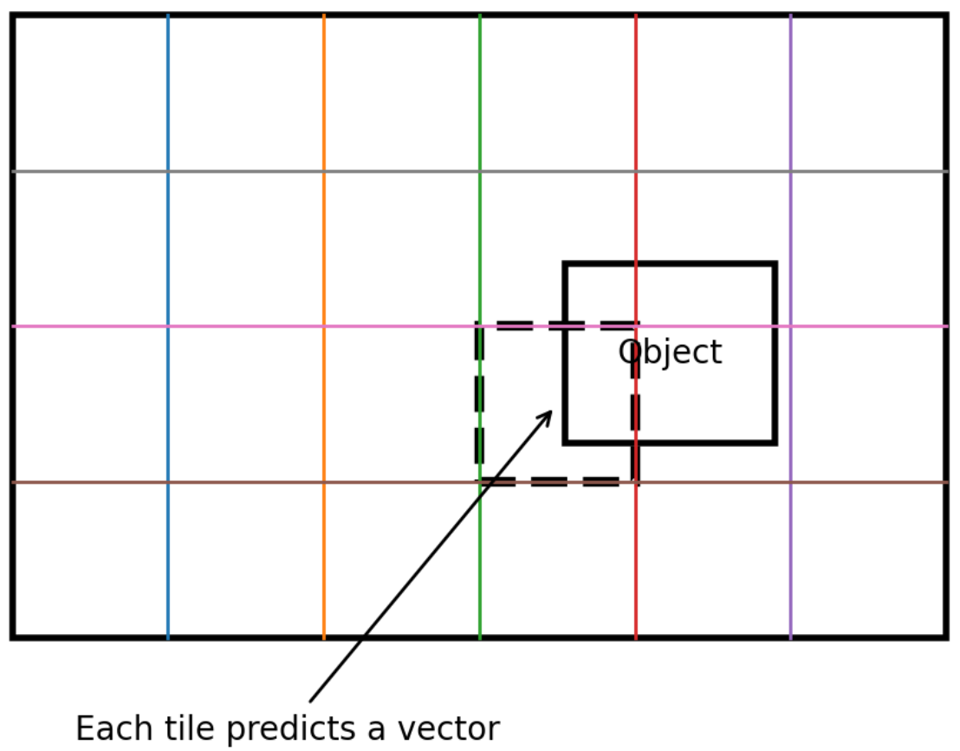 | - Pc is the confidence that the object exists  - Bx, By are the x, y coordinate of the object  - Bw, Bh are the width and height of the object  - C1, C2 are the types of the object  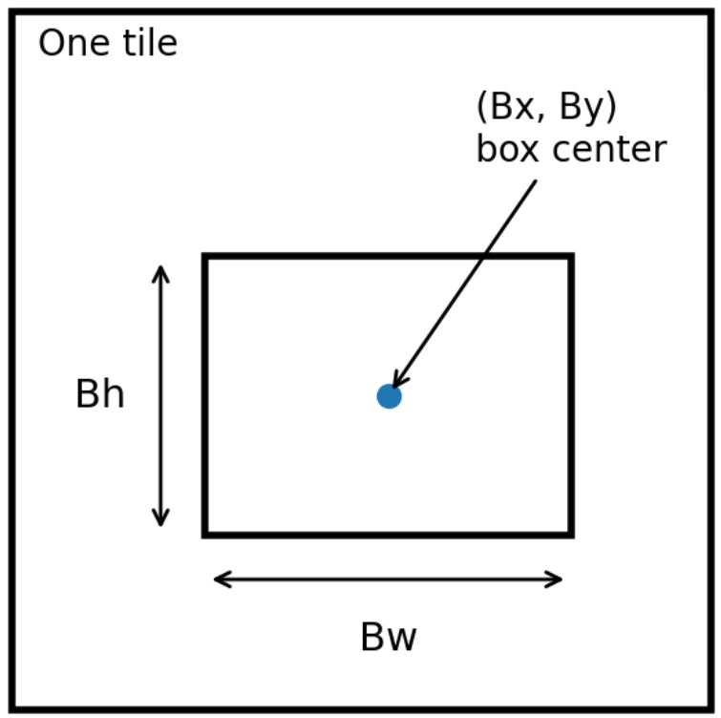
For overlapping boxes, divide the intersection area by the union area, and remove the one with a lower Pc if the result is high.  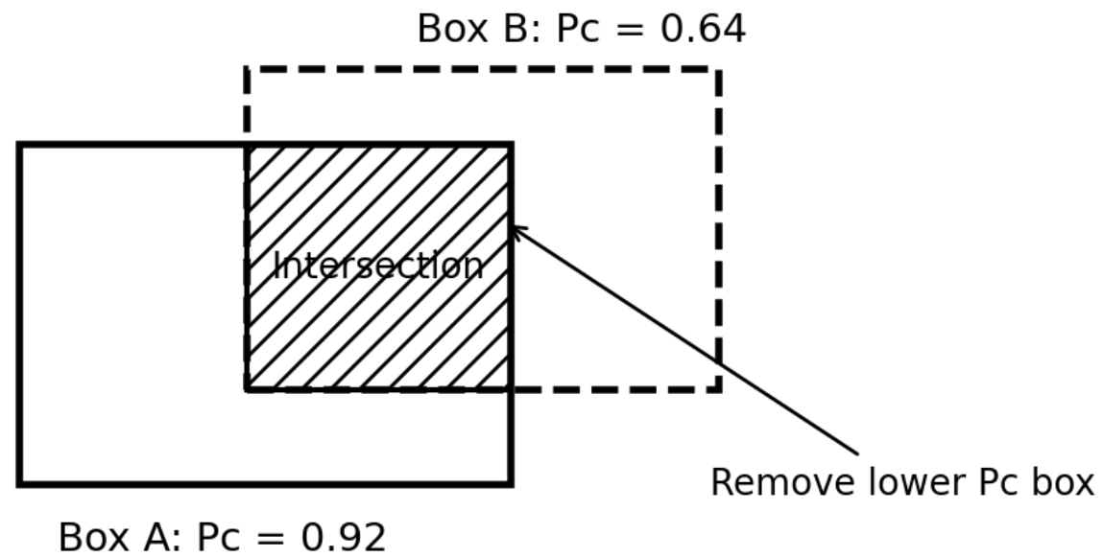 | For more objects in the same grid, the vector can simply be expanded: [Pc … Pc …]  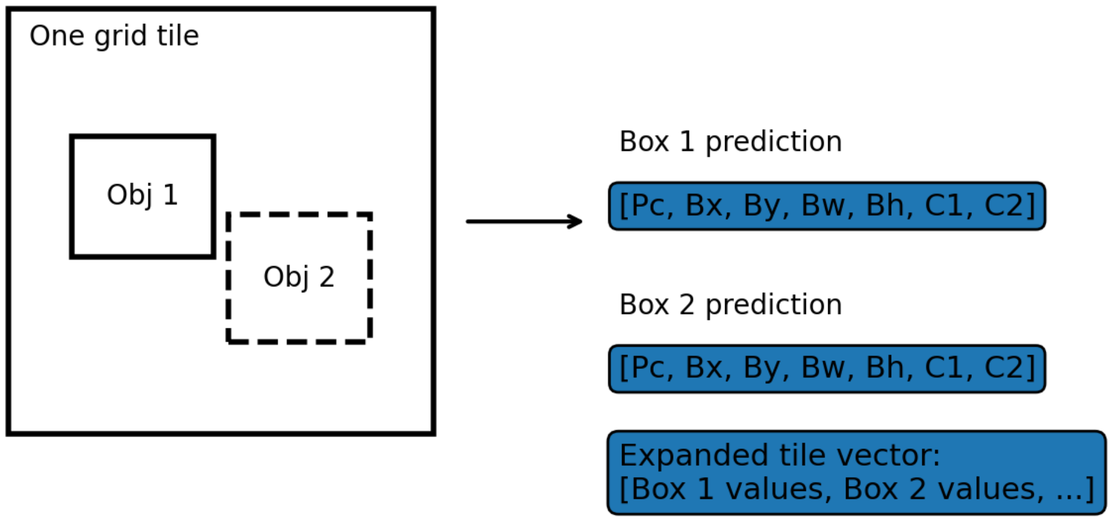

2.1 CNN
CNNs include many layers, and after going through those layers, the image becomes informative. One of the goals of this project is to reduce the number of layers without losing accuracy.

2.1.1 Convolution layer
An image can be represented as a matrix of pixel values. A filter matrix is moved across the image. At each position, the filter is multiplied with the corresponding image window element by element.
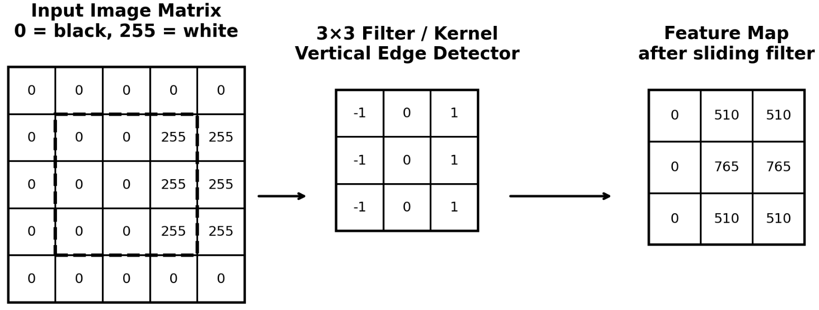
After the filter is applied to every position in the image, the output is a feature map. Larger values in the feature map mean stronger matching pattern in that part of the image.

Different filters can detect different types of features, such as vertical edges, corners, circle-like shapes, or textures.
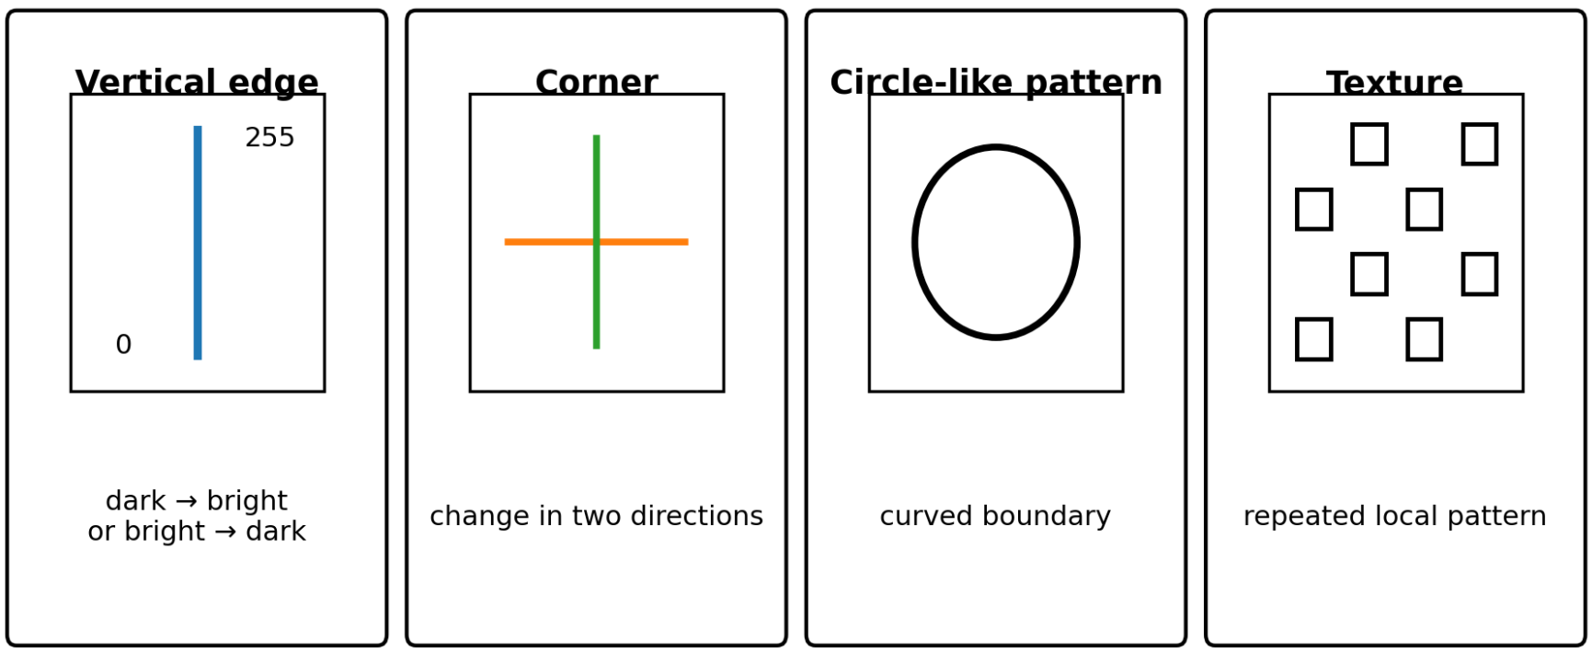
In traditional image processing, these filters can be manually designed. In CNNs, the filters are usually learned automatically during training.

With this knowledge, I tried a mini program:
Input  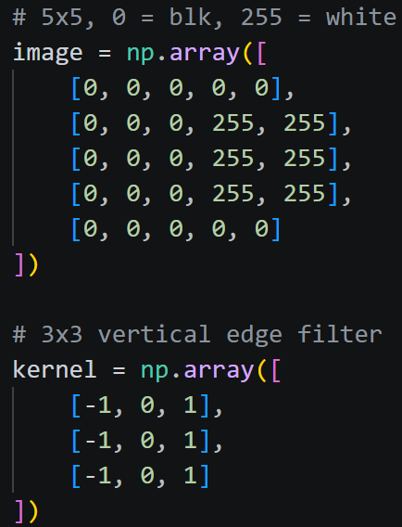 | Process  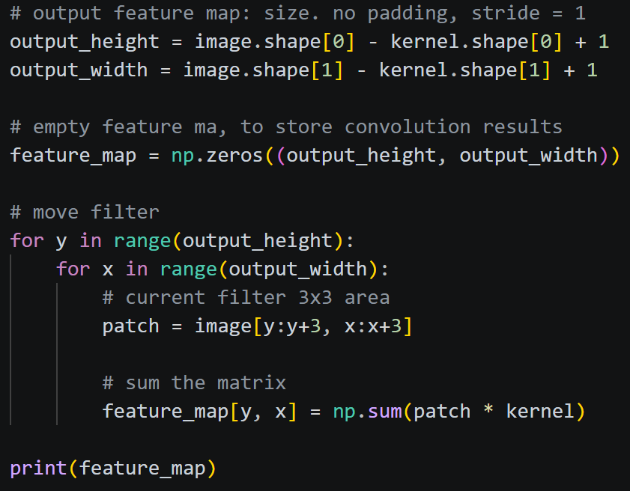 | Output  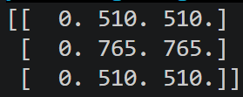

2.1.2 1x1 Convolution layer
Used to reduce the number of feature maps.

2.1.3 Activation layer (Leaky ReLU)
Scan values in a feature map
- if positive value: keep it
- If negative value: multiply it by 0.1 (or a number between 0 and 1)

2.1.4 Max pooling layer
Simplify by taking the maximum value in a window, e.g.:
[1, 2, 3, 4] => [4]

2.1.5 Fully Connected Layer
The fully connected layer combines all features and converts them into the final prediction output. The format can be [Pc, Bx, By, Bw, Bh, C1, C2] as mentioned before. It can be further flattened to a long vector. For example, YOLOv1 is 7×7×30.

3. Process of YOLOv1 CNN

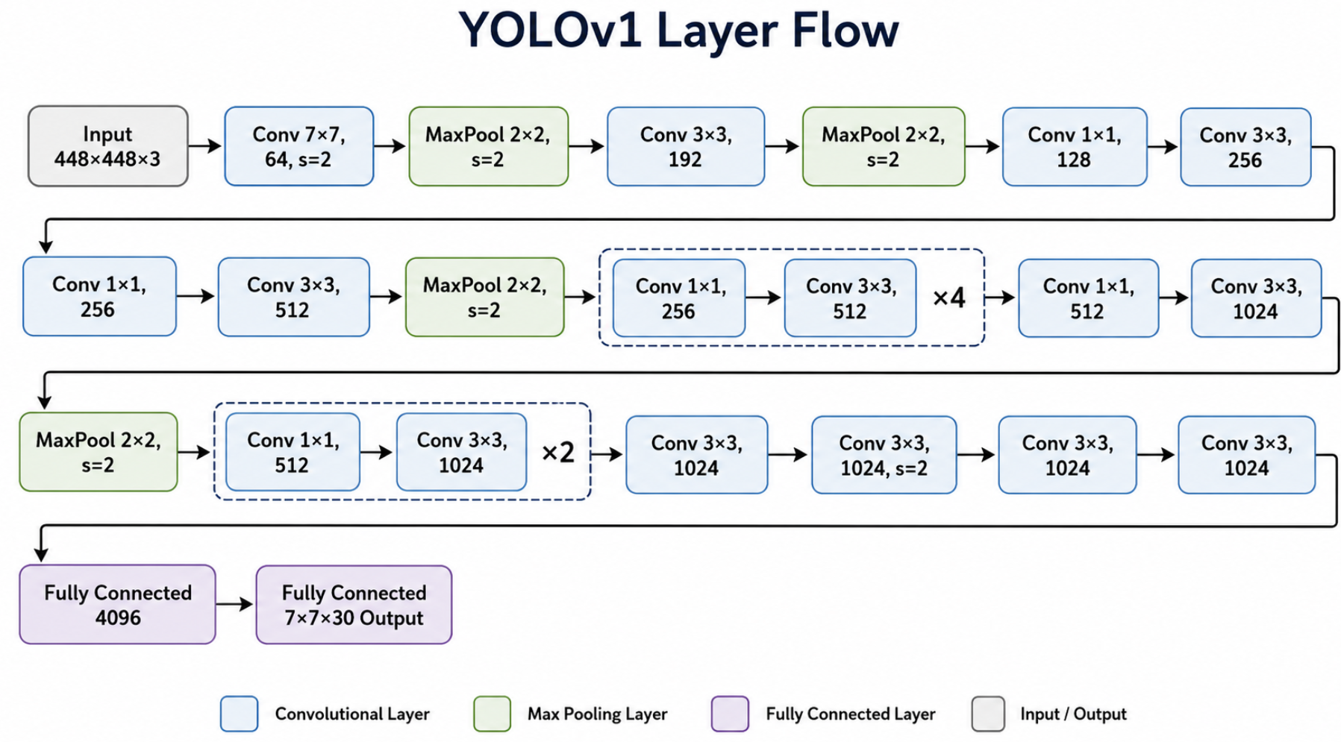
Later, I may compare the latest YOLO model with YOLOv1 to see what it changed to increase speed while maintaining accuracy.

